1. 
2. 
3. **RequestSpecification:**
   1. Interface.
   2. All the methods required to prepare HTTP request.
4. 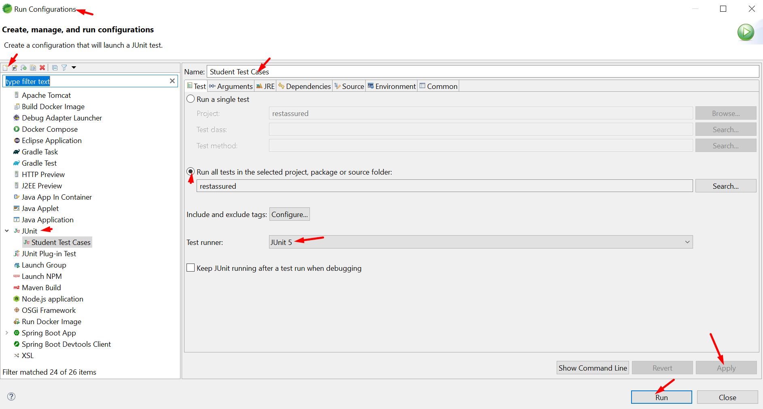
5. Let’s write test cases.
6. 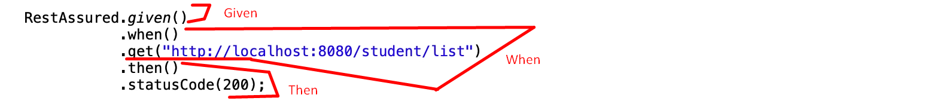This is BDD style for writing test case.  
   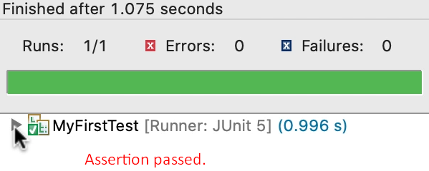  
     
   The following is also BDD style but here we broke the method call chain  
   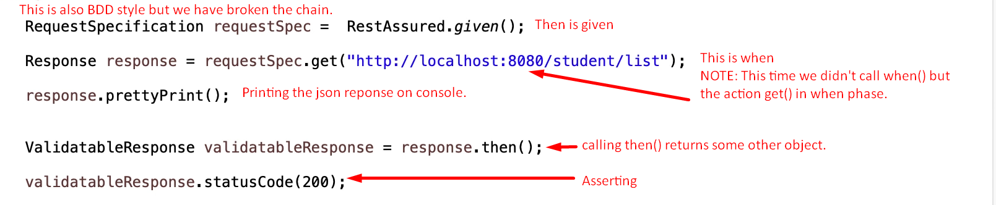
7. 